[1]

Template for Preparation of Papers for IEEE International Symposium on Computer, Consumer and Control (IS3C2023)*

First A. Author, Second B. Author, Jr., and Third C. Author, Member, IEEE

*Abstract*— This electronic document is a “live” template. The various components of your paper [title, text, heads, etc.] are already defined on the style sheet, as illustrated by the portions given in this document.

1. **Abstract Length without reference: 1 page, including figures, tables, etc**
2. **Abstract without image: Text must be less than 2500 characters excludingspaces, title, author names, and affiliations.Abstract with an image: Text with an image must be less than 2000characters excluding spaces, title, author names, and affiliations.**
3. **AbstractSize: US Letter (8.5" x 11") or A4 (210mm X 297mm)**
4. **Fonts:Embed ALL fonts in your PDF file. Avoid the use of Type 3 fonts.**
5. **AllowedFile Size: 5.0MB**
6. **Do NOTapply security settings to your PDF file.**
7. **Deviations from the above abstract specifications could impede the review ofyour abstract and result in rejection.**
8. **ALL submissions must be made on-line from this web site.**
9. **Email submissions will NOT be accepted.**
10. **Figures and Tables: Positioning Figures and Tables: Place figures and tables at the top and bottom of columns. Avoid placing them in the middle of columns. Large figures and tables may span across both columns. Figure captions should be below the figures; table heads should appear above the tables. Insert figures and tables after they are cited in the text. Use the abbreviation “Fig. 1”, even at the beginning of a sentence.**
11. Table Type Styles

| Table Head | Table Column Head | | |
| --- | --- | --- | --- |
| Table column subhead | Subhead | Subhead |
| copy | More table copya |  |  |

a. Sample of a Table footnote. (Table footnote)

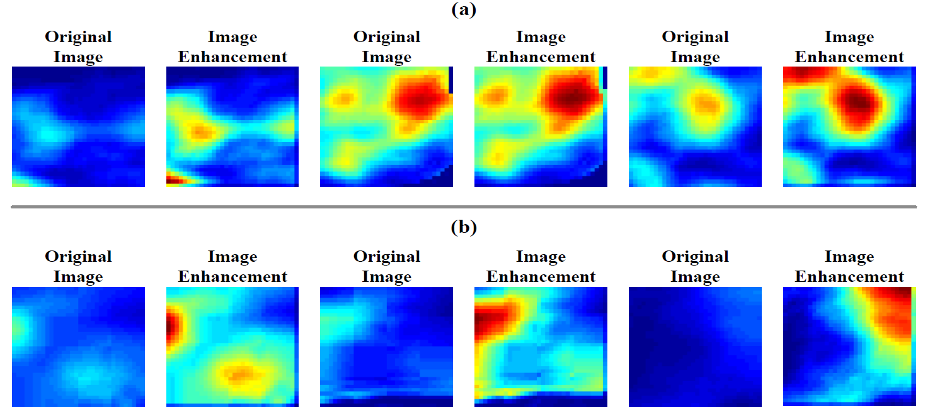

1. Example of a figure caption. *(figure caption)*

References

1. G. O. Young, “Synthetic structure of industrial plastics (Book style with paper title and editor),” in *Plastics*, 2nd ed. vol. 3, J. Peters, Ed. New York: McGraw-Hill, 1964, pp. 15–64.
2. W.-K. Chen, *Linear Networks and Systems* (Book style)*.* Belmont, CA: Wadsworth, 1993, pp. 123–135.
3. H. Poor, *An Introduction to Signal Detection and Estimation*. New York: Springer-Verlag, 1985, ch. 4.
4. B. Smith, “An approach to graphs of linear forms (Unpublished work style),” unpublished.
5. E. H. Miller, “A note on reflector arrays (Periodical style—Accepted for publication),” *IEEE Trans. Antennas Propagat.*, to be published.

1. .